Chapter 9, Solution 76.

(a) 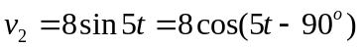
v₁ leads v₂ by 70º.

(b) 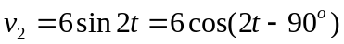
v₁ leads v₂ by 180º.
(c ) 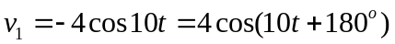
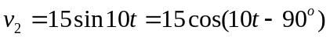
v₁ leads v₂ by 270º.

